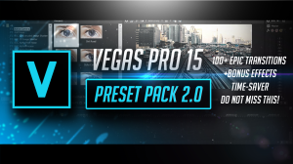
Sony Vegas Mega Transitions & Effects Pack By Pro Edits #PRO-V4
- zip
MegaPresetPackByProEdits.zip (0.81 GB)
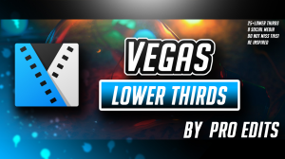
Sony Vegas Minimal Lower Thirds Pack By Pro Edits! #PRO-V3

Additional Information About Product:
See more here: PayLoadz Store
Trouble in downloading?. Click Here to learn more
Order Summary
Your order has been sent to:
Lawrenceclemens@gmail.com
Order reference:
3SL02069VN619845X
Order date:
11/7/2017 10:10:00 PM
Amount billed:
$44.98
This page will be available for up to thirteen days. Your IP address is 173.50.66.158 was logged for this purchase. The number of refreshes or reloads on the web page may cause your download link link to expire.
Please contact pr0edits911@gmail.com if you have any questions regarding your product or experience any download problems.

