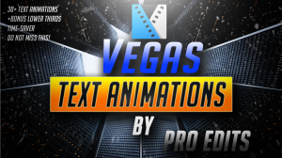
Sony Vegas Mini Text Animation Pack By Pro Edits! #PRO-V2
- Zip TextAnimationPackByProEdits.zip (0.15 GB)
Additional Information About Product:
See more here: PayLoadz Store
Trouble in downloading?. Click Here to learn more
Order Summary
Your order has been sent to:
Lawrenceclemens@gmail.com
Order reference:
9SE23237E7763325M
Order date:
11/7/2017 10:03:00 PM
Amount billed:
$9.99
This page will be available for up to thirteen days. Your IP address is 173.50.66.158 was logged for this purchase. The number of refreshes or reloads on the web page may cause your download link link to expire.
Please contact pr0edits911@gmail.com if you have any questions regarding your product or experience any download problems.

