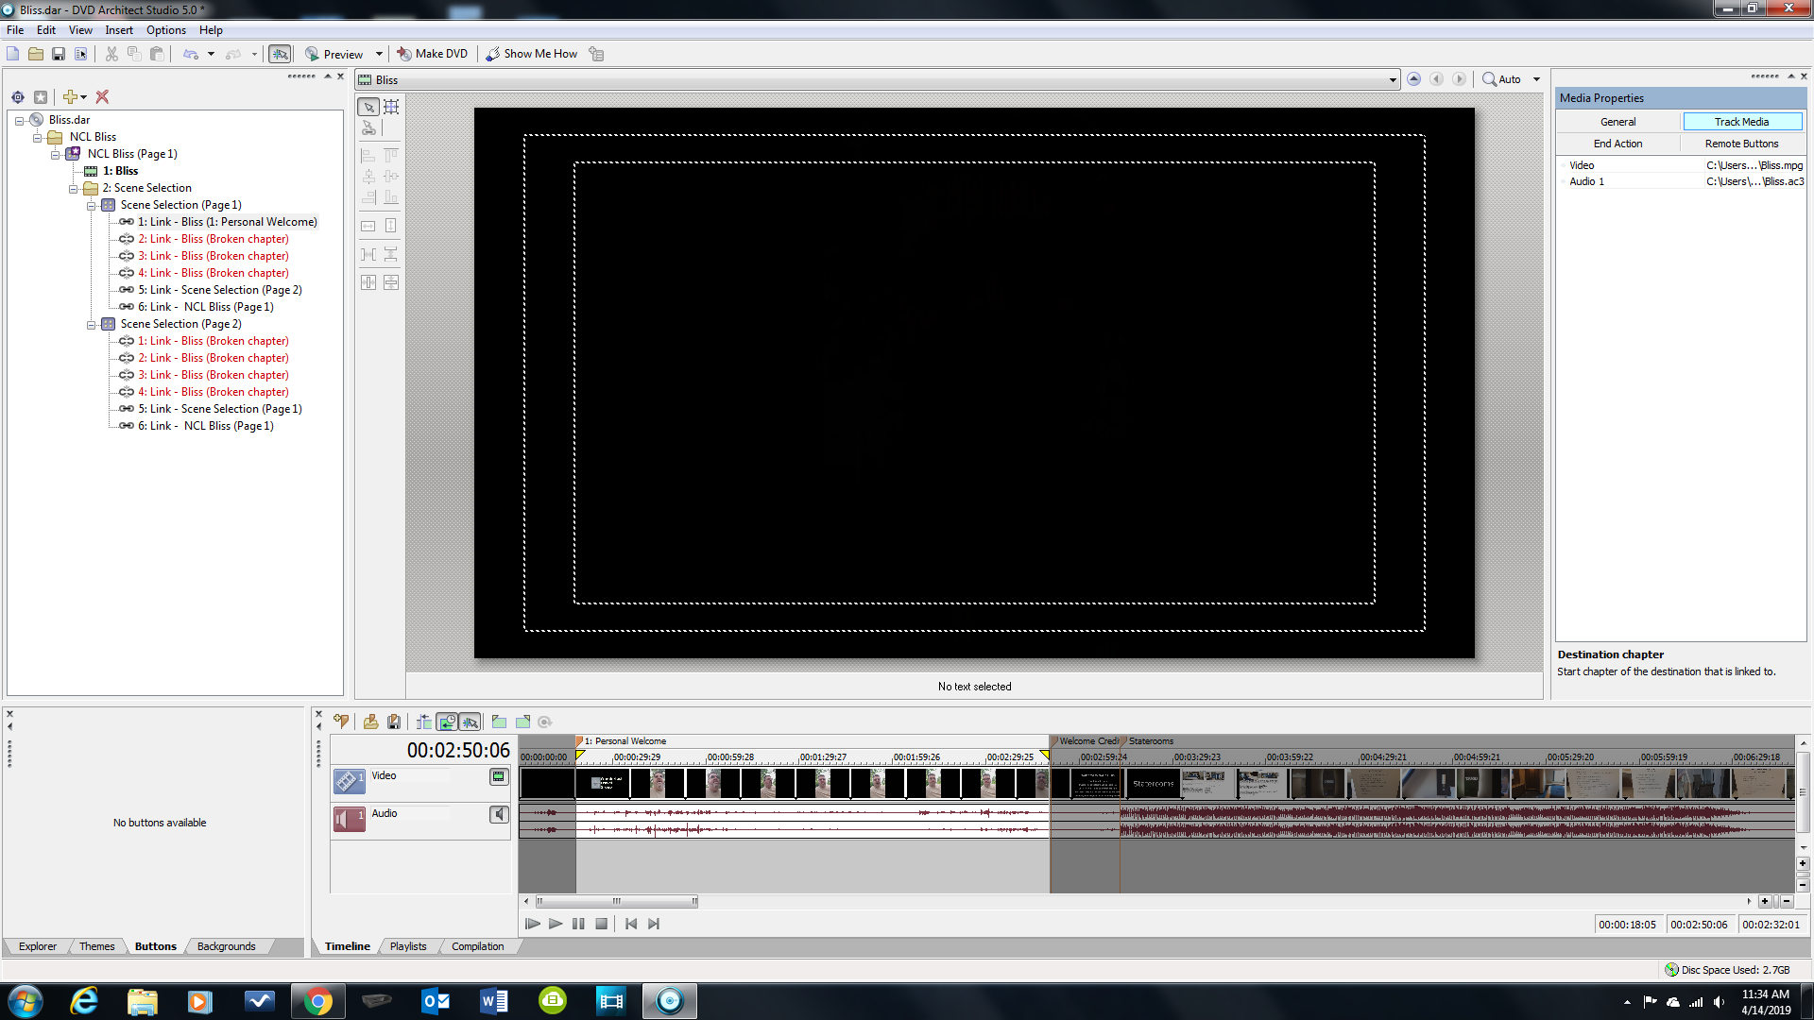

As you can see when I set the in/out for Personal Welcome it shows up for link 1. When I go back to the menu to establish button properties it shows correctly.
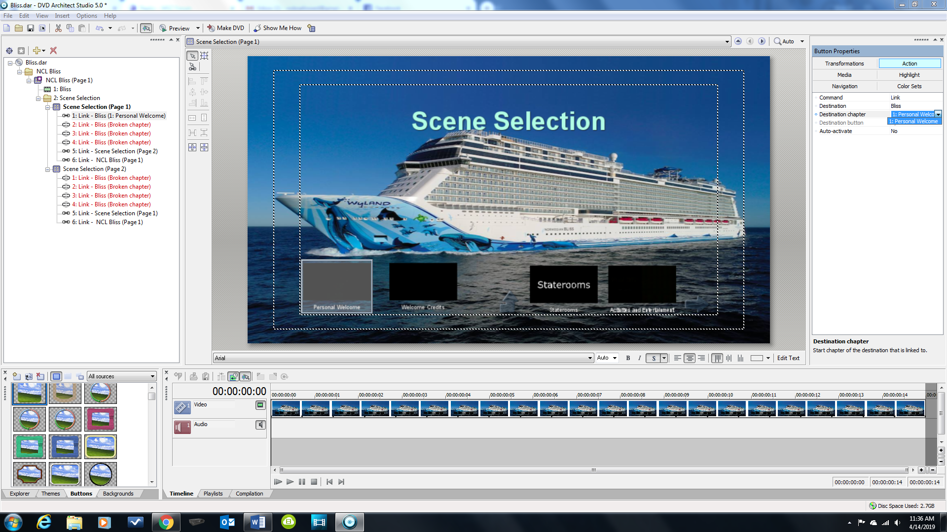

So I click on the Welcome Credits button and go set the points for that. However if you notice the overview window my Link 1 has changed.

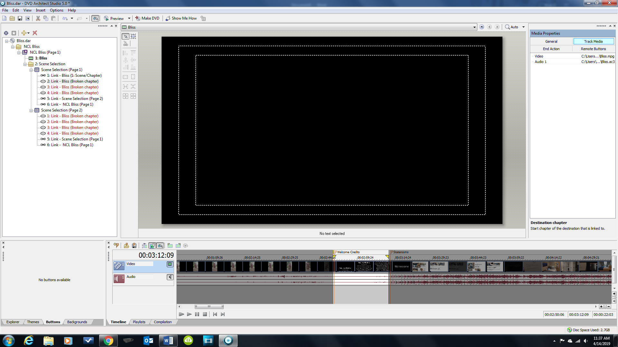

When I go back to set button properties for #2 it looks like this
