I compared my properties in Vegas 13 and DVDA and this is what I have.

Vegas 13
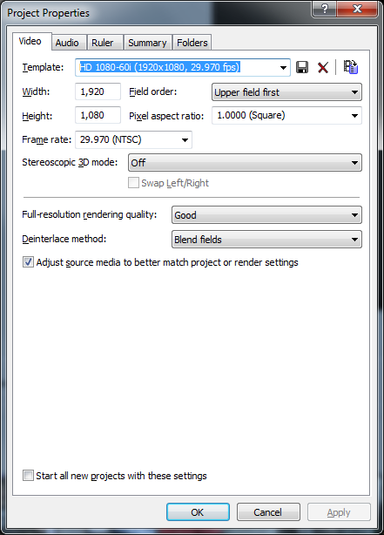
DVDA 5
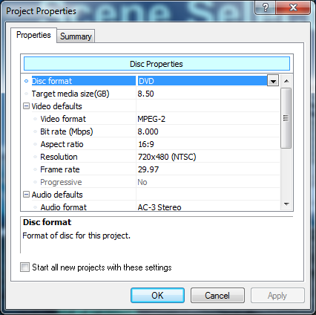

Is it going to cause an issue if the resolution doesn’t match the Project Properties in Vegas 13? Would that cause my project too big for media error?

